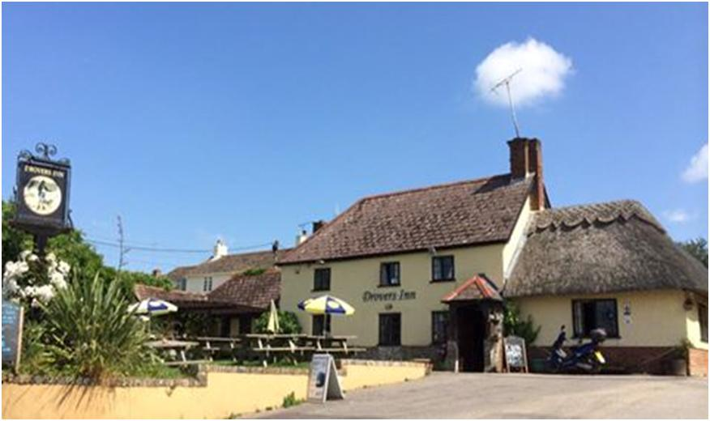
gUSSAGE cOMMUNITY BENEFIT SOCIETY LIMITED Reg. No. 7116
Our aim is to secure the long term future of The Drovers Inn as a flourishing pub for the benefit of the community, by vesting ownership in a society controlled by the community and by running the pub profitably

The society proposes to raise funds to purchase, re-furbish and maintain The Drovers Inn. It will lease the pub to a professional tenant who will be responsible for the operation of the public house.

“You are invited to pledge your support for a community enterprise set up to secure the future of The Drovers Inn, Gussage All Saints”
pledge
FOR THE COMMUNITY PURCHASE OF
THE DROVERS INN
official SHARE LAUNCH target: 22nd mAY 2015
estimated CLOSING DATE: 3rd july 2015
OUR TARGET IS £155,000 + YOU CAN pledge £300 - £45,000

Summary
We are seeking investors who wish to become members of the Gussage Community Benefit Society Limited (Reg. No. 7116) that plans to buy The Drovers Inn, Gussage All Saints, Dorset. We plan to run it as a typical village pub, for the benefit of the residents of Gussage All Saints and surrounding villages, as well as visitors to the area. We aim to find a professional tenant who will run The Drovers as a profitable business with all your support and provide a service to the village and to visitors to the area and support other local businesses and tourism within East Dorset. More importantly, it will put the heart back into the village as a place for social gathering, providing good food, cultural activities, a place to meet people and exchange information and it will promote a cohesive and friendly community in the area. It is our intention that the pub will work closely with and in support of the other community facilities and clubs in the area, in particular the village hall and the part-time social club.
If you make an investment you will become a member of Gussage Community Benefit Society Limited, which is a society with limited liability run for the benefit of the local community. You will be a co-owner of the freehold of a traditional Dorset pub, in a beautiful setting and will always receive a friendly welcome in the pub that you own.
The performance of the tenant that we select is critical to the long term success and sustainability of the enterprise and it is essential that we maintain good communication with and support for our tenant to achieve this.
Members will need to invest a minimum of £300. Each member will have an equal say in the enterprise no matter how much you invest. The initial Management Committee that have formed the Society are accountable to the membership and will, in future, be elected by the Members. Members will receive updates via the website www.droversinngussage.com , newsletters and be entitled to attend the Annual General Meeting and other special general meetings that may be called from time to time.
Professional expertise has been sought from Mr J P Stone FRICS, RICS from Stonesmith Chartered Surveyors, Valuers and Agents. On 20 April 2015 Their Market Value of the freehold property in its current condition being closed and boarded was £350,000 excl VAT. Refurbishment work required to re-open the pub is estimated at £50,000. Based upon historic trading records the potential initial turnover stated by the independent Valuer is around £220,000 net of VAT from its current and boarded up condition. A second valuation has indicated an initial turnover of £230,000. However, a significantly higher turnover can be achieved with a professional tenant delivering a great food offering in welcoming atmosphere with consistently high standards of customer service.
We aim to raise a total of £400,000.00 from a community share offer together with commercial loans. This will be used to purchase the building freehold with associated costs and taxes and get it ready to be re-tenanted. The Society will agree a lease with the tenant who will run the separate licensed business selling food and drink in our premises and pay rent to the Society at a level that will reflect the profitability of the business. The rental income will provide the revenue required to cover:
- loan interest, capital repayment and meet any corporation tax liabilities,
- maintain the building and enhance the facilities
- facilitate the withdrawal of shares from time to time, and may pay interest to the investors.
We firmly believe that the business will be profitable, but if it is not, the Society owns a valuable asset – the building and land associated with it - which can be sold in order to return funds to investors. Your investment is in the building and land – the bricks and mortar, not the licensed business. This is a great opportunity to invest in a worthwhile community enterprise that will provide a valuable service to its members, users and future generations.
The business plan will evolve as we move through the process and negotiate to acquire the pub and recruit the tenant and, as we achieve success with any grant applications.

Gussage Community Benefit Society Limited – Pledge Form
To pledge to become a member of the Gussage Community Benefit Society Limited please complete this form and hand it to a member of the Management Committee or send it to Gussage Community Benefit Society Limited at the address below or email a scanned copy to sally.marlow@btconnect.com.
To pledge your support you must be 18 years of age or over). Each individual must complete a separate form.
I would like to pledge my support for the Gussage Community Benefit Society
I am over 18 years of age

I wish to pledge for shares (share cost £1 each, minimum 300, maximum 45,000)
Value of the shares pledged

Name: ............................................................................................................................................................
Address: .........................................................................................................................................................
Postcode: .......................................................................................................................................................
Tel No: ............................................................................................................................................................
Email: ..............................................................................................................................................................
I understand that I will be asked to formalise this pledge in an application for membership once I have had the opportunity to review the detailed business plan and share prospectus that will be available from 22nd May 2015.
Signature........................................................................................................................................................
Date: ...............................................................................................................................................................
Please return this form to a member of the Management Committee or post to:
To: Mrs Mal Madell (The Treasurer), Teachers, Gussage All Saints, Wimborne, Dorset BH21 5ET
You can also phone or email your pledge to:
Mal on 01258 840058 or Sally on 01258 840531 or email lesandmalmadell@btinternet.com or sally.marlow@btconnect.com
Please note: by pledging to become a member of Gussage Community Benefit Society Limited, I agree to my name, address, phone numbers, email address and the number of shares I wish to purchase being held on a computer database. This information will only be used for the purpose of maintaining a register of members and for posting notices regarding the activities of Gussage Community Benefit Society Limited. This information will not be passed to third parties.

